[Blueprints, Doctrine, and Production](http://fractalsoftworks.com/2018/02/12/blueprints-doctrine-and-production/" \o "Permanent Link: Blueprints, Doctrine, and Production)

蓝图系统，势力设置以及舰船订购

Posted February 12, 2018 by Alex in [Development](http://fractalsoftworks.com/category/development/)

Translation by Jn_xyp 翻译：Jn_xyp

How starships get produced has been heavily abstracted so far – there’s a colony, and it spawns fleets made up of faction-appropriate ships, and that’s about all there was to it. To be fair, that’s all that *needed* to be there, since it was not something the player could interact with in more detail than attacking those fleets.

目前，游戏中舰队的生成是十分抽象的——仅仅是从殖民地根据派系产生有相应舰船组成的舰队。讲道理，在玩家不能够与舰队产生除了战斗以外任何更加细致的交互的情况下，现有的机制是足够的。

Now that the player can establish colonies and manage a faction of their own, we need more detail. Not so much that it’s a chore to manage, but enough to cover the things the player will naturally want to do.

现在，当玩家可以创建殖民地并经营自己的势力的时候，就需要添加更多的相关细节了。这些细节并不应该过于繁复而导致难以把握，但是仍然应该包括玩家一些自然而然想做的事情。

If you’ve been keeping track of the backstory, most heavy manufacturing in the Sector is done using “blueprints” – precise specifications for building a ship or a weapon, that an automated factory can use to build the item. Copying these is difficult-to-impossible, and their dwindling supply contributes to the gradual decline of the Sector. This is the base we’ll use to develop the manufacturing mechanics, making adjustments to cover the demands of gameplay, as needed. That is to say, if blueprints have to work a certain way for the gameplay to come together, then hands will be waved.

如果你读过之前的开发日志的话，大部分星区中的工业生产都是依赖“蓝图”来进行的。“蓝图”是一套关于武器和舰船资料的详尽指示，自动化的工厂可以依靠它们来生产各种物品。对于蓝图的复制是几乎不可能的，而其供应的减少也是导致星区衰落的主要原因。蓝图和生产系统的出现意在整合游戏的游玩方式，并给游戏提供一个合理化的解释。

Blueprints

蓝图

A “blueprint” is an item the player can find and right-click to “learn”. For example, they might acquire the blueprint for a Medusa-class destroyer or a Heavy Mauler, a ballistic weapon. This works similarly to how players learn new hull-mods. After a blueprint has been learned, the player’s heavy industry becomes capable of producing the items in question – there are lots of details here, and we’ll get to those in a bit, but that’s the basic system.

玩家可以在蓝图物品上点击右键来进行“学习”。比如，如果得到了美杜莎-级驱逐舰的蓝图，或者实弹武器重型撕裂者的蓝图，就像玩家学习船插一样，玩家所有的工厂在玩家学习蓝图之后就具有了生产这些武器或舰船的能力。虽然具体的细节比较复杂，但这就是基本的游戏机制。

[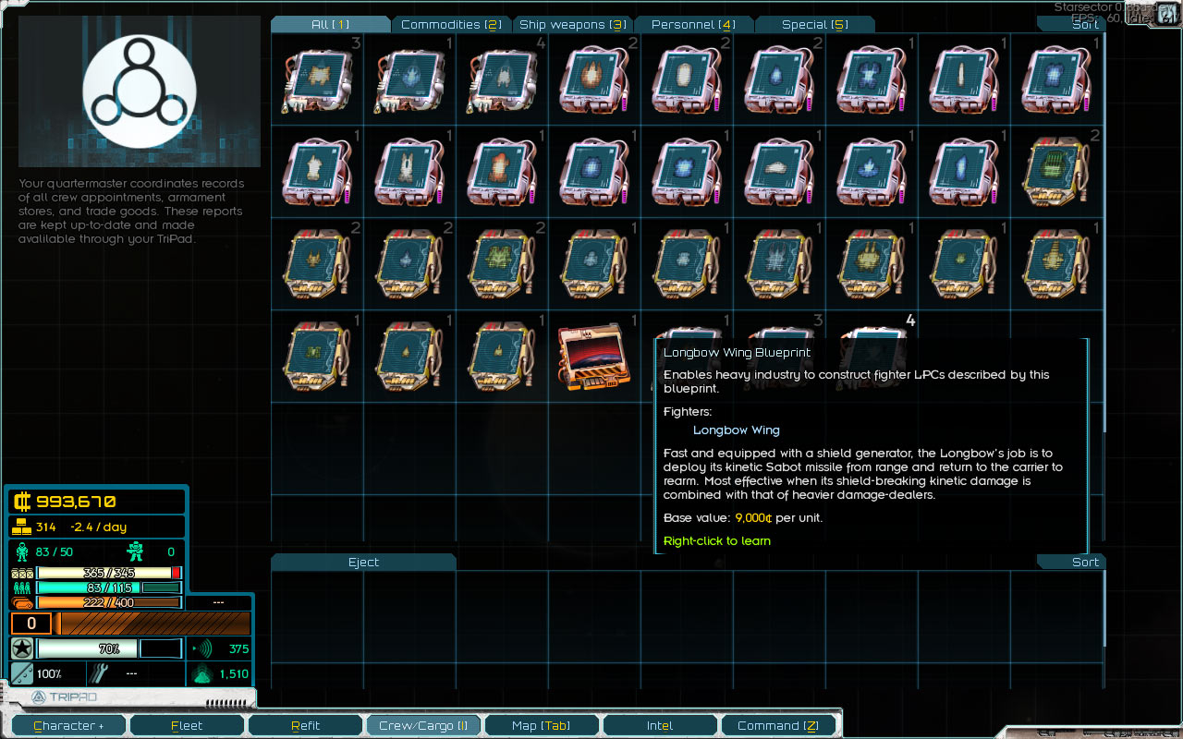](http://fractalsoftworks.com/wp-content/uploads/2018/02/blueprints.jpg)

This is in line with the design principle that exploration should yield *stuff* that feeds into the player’s colony-building. The rare blueprints are to be found on the Sector’s fringes, and not for sale at one core world or another.

这种机制与游戏的概念相符，即在探索过程中所发现的东西应该能被玩家的殖民地所利用。稀有的蓝图不在核心星系的市场上售卖，而是出现在星区的边缘地区。

That’s a lot of blueprints, isn’t it?

会不会有巨多的蓝图？

Indeed it is. If we’ve got one blueprint per ship, weapon, and fighter, it’s… oh, something like 100 for the core game. If you include mods, the total easily gets into the low thousands.

如果给每一种舰船、武器和战机都提供一个蓝图的话，那么原版游戏中就得大概有超过100种。如果添加mod的话大概会有接近上千种。

That’s too much to ask the player to acquire from random drops. Not everything is guaranteed to be available in every campaign to begin with, but if you raise the numbers of possible drops, and the player, say, only gets a hundred total opportunities for a rare blueprint from different locations on the fringes – it just doesn’t add up. Having to acquire blueprints for basics such as a “Light Machine Gun” also isn’t very exciting.

如果让玩家仅仅通过随机掉落来收集这些蓝图的话就太多了。不是所有的蓝图在游戏一开始就必须是可用的，但是如果在蓝图的总数很多的时候，玩家通过探索星区边缘得到的蓝图总量却是有限的，就显得很不合理。而且捡到像是“轻机枪”之类的蓝图也没有什么意思。

We need to cut the numbers drastically here. The first step is making some blueprints (such as the aforementioned LMG) known from the start, by every faction. Let’s say they’re so common they’re burned into autofactory firmware. Or the blueprints themselves are so common that the player doesn’t need to be bothered with it, and we can just assume there’s always some around. Or maybe the tech is simple enough that they don’t require blueprints at all.

我们需要想办法来减少蓝图的数量。一个办法是将一些蓝图（例如轻机枪）设为派系默认保有，或者已经被包含在了自动生产系统里；抑或是因为这种蓝图广为人知、遍地都是，玩家不需要特别地去费心。再或者是生产所需的技术足够简单，甚至不需要蓝图就可进行生产。

The second step is bundling up certain not-entirely-common, but also not-very-exciting blueprints into “packages” – a single item which lets you learn multiple blueprints at the same time.

另一个办法是将一些不太常见的，但也不是特别令人兴奋的蓝图打成一个蓝图包，可以让玩家通过一次学习掌握多个蓝图。

For example, there’s a “Low-tech Blueprint Package” that lets the player learn a couple of the more common ships and weapon from that design period. It’s not going to include the Onslaught-class Battleship, but it will include the somewhat less exciting Dominator (cruiser) and Enforcer (destroyer). Unlike the rare single-item blueprints, these will probably be found for sale – more or less reliably, to avoid having to repeatedly sift through markets looking for one.

例如，可以设定一个“低端科技蓝图包”，让玩家可以一次性学习多个那一时期的舰船和武器设计。这种蓝图包不至于会包含攻势-级战列舰的蓝图，但会包括一些不太牛逼的例如统治者-级巡洋舰和压迫者-级驱逐舰。不同于那些稀有的蓝图，这些蓝图很可能可以被买到，以避免玩家在市场间来回奔波寻找某套蓝图。

[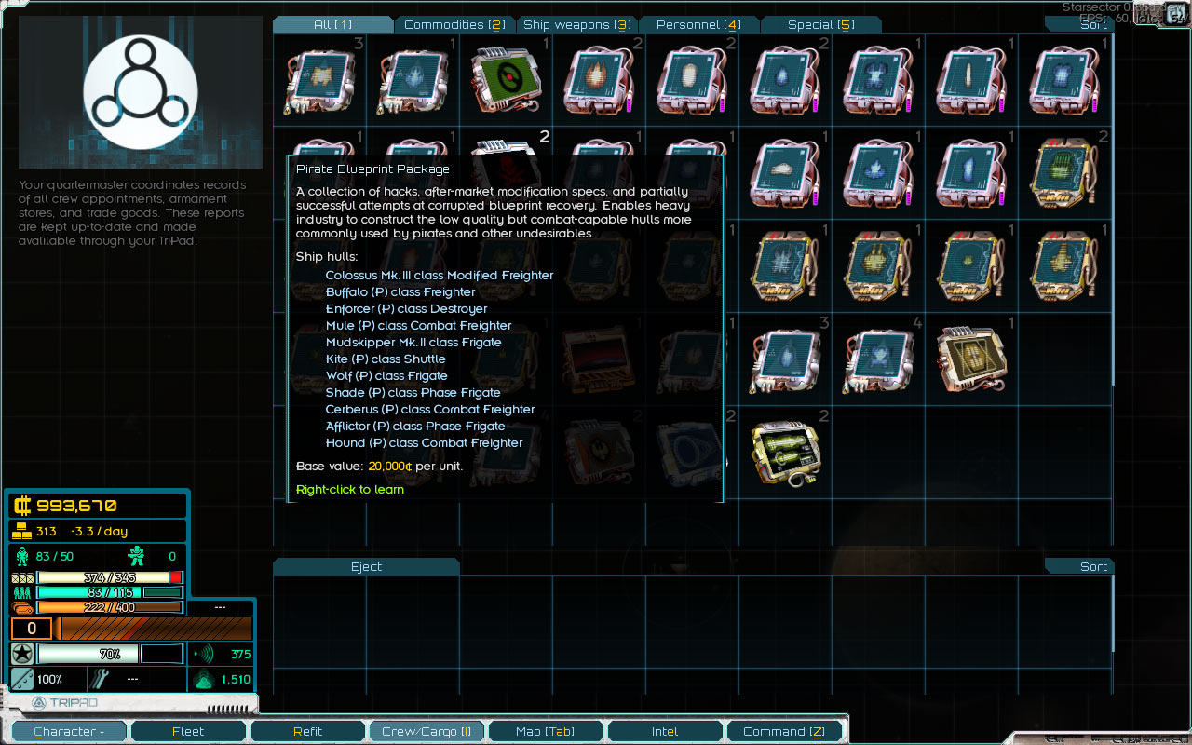](http://fractalsoftworks.com/wp-content/uploads/2018/02/bp_package.jpg)

Presumably, mods would provide their own blueprint packages for the workhorse ships and weapons, and only designate a few individual blueprints as “rare”.

根据设想，游戏的模组也应当提供他们自己舰船和武器的蓝图包，并且应当仅将个别蓝图定义为稀有。

This two-pronged approach should bring the number of rare blueprints down to something manageable.

这种双管齐下的方法应该能够大幅降低蓝图的数量，以达到一个可控的程度。

What will the player want to do?

玩家想干啥？

Given the blueprint-learning system, I think there are two core things the player will want to be able to do.

通过添加蓝图学习系统，我认为玩家应当会主要集中于做两件事：

The first is being able to build the ships and weapons for their own use. If they find a “Light Needler” blueprint (a rare, highly effective anti-shield weapon), you can bet the first thing the player will want to do is make a bunch of them to equip their ships.

第一件事是生产自己的舰船和武器。如果玩家得到了“针刺”（罕见的高效破盾武器），你可以预料到玩家会立刻让舰船大量装备该武器。

The second – the player controls colonies, and those produce their own fleets – patrols, trade fleets, and other such. The composition of these is based on what blueprints are available, and I think many players will want to be able to fine-tune the fleets further, even if it has limited practical impact on their effectiveness.

第二种 - 玩家控制殖民地，而殖民地制造他们自己的舰队 - 巡逻队，贸易队等。 舰队的组成基于玩家可用的蓝图，而我认为，许多玩家会想要不停地微调他们的舰队组成，即使这些调整对于舰队的战力影响有限。

For example, if they’re aligned with a specific faction, they might want to use similar ships or weapons. In the context of using mods, the player should be able to play as a faction the mod adds – using their weapons and ships, and – provided those cover all the bases – not much else. We also want to avoid any situations where learning a new blueprint is a bad thing.

例如，如果强迫症玩家想要和其所属的势力保持一致，他们就会想使用类似的舰船和武器。在使用模组的情况下，玩家可以加入模组势力 – 使用他们的舰船和武器 – 试图在所有基地提供相同的配置 – 没别的了。我们需要避免学习新蓝图是一件不好的事的情况。

Let’s talk about fleet composition first.

让我们先说说舰队的组成。

Blueprint Management

蓝图管理

The first thought I had was letting the player enable the blueprints they want. This is broadly workable, but gets weird if they disable too many things. For example, how does a colony create a trade fleet if all freighters are disabled? So, instead of a “hard” on/off setting, blueprints can be “prioritized”.

我一开始的想法是允许玩家禁用他们不想使用的蓝图，但这很显然不具有实践性。如果玩家禁用了太多的蓝图，情况就会变得很鬼：如果禁用了所有货舰的蓝图，那殖民地如何创建贸易舰队呢？所以，使用蓝图的“优先使用”来替代彻底的“禁用”。

If a fleet needs a small freighter, and one kind is prioritized? It’ll use that. If there isn’t a priority one, it’ll pick among all the available ones – and since there’s a “base” set of blueprints that’s always known, we don’t need to worry about specific ship types being entirely unavailable.

如果舰队需要一艘小型货舰，并且有一种货舰蓝图被设为优先，那么系统会采用优先蓝图。如果没有设定优先蓝图，那么系统将会从所有的可用蓝图中选择。因为总会有一些基础的已知蓝图，所以不会出现没有办法建造某种类型船只的情况。

The player can do the same thing with weapons and fighters, determining how the ships in their fleets will be outfitted.

玩家同样可以如此管理武器和战机的蓝图，以此来定义舰队的武器装备。

Management UI

管理界面

The sheer possible number of ships and weapons for the player to manage is, once again, a challenge. If there are 500 known ships, putting them in a simple list and asking the player to check the ones they want to prioritize is unreasonable – we need to provide an interface that makes this as smooth as possible.

玩家可以管理的舰船和武器数量再次成为挑战：如果玩家有500种已知船只，把它们塞进一个列表里，并让玩家一个个调整是否优先肯定是不合理的。我们需要提供一个尽可能易用的界面。

So, what are our design goals? One is to make the basic task of “prioritize everything for a particular style” quick and easy, and for that to serve as a base for further fine-tuning; this is for the player that’s going to be interested in customizing their faction in that way.

所以，界面设计的目的是什么？目的之一就是让“将所有东西设定为优先使用一种风格”这一任务变得简单，并以此作为在其基础上微调舰船配置的基础，面向于那些希望通过这种方法来自定义自己舰队的玩家

To that end, every ship/weapon/etc gets a new property – the “design type”. In the core game, that’s “Low-tech”, “Midline”, and “High-tech”, with a few other ones (such as designs hacked together by the Luddic Path or pirates). Modded factions would presumably give their ships and weapons a new design type, making them easier to identify and select.

为了达到这一目标，每一种舰船武器和其他物品都将会有一种新属性：设计风格。对于原版游戏，可用的风格包括“低端科技“，”中端科技“，“高端科技”，以及一些其他的风格（例如路德教会和海盗的“魔改混合”）。模组也应当给出它们各自的舰船、武器设计风格，以确保其能被简单地分辨和选择。

The UI lets the player filter blueprints by design type and then press a single button to prioritize everything matching the filter. Blueprints can also be prioritized individually by clicking on them.

这套界面允许玩家通过设计风格来筛选舰船，并一键将所有符合的舰船蓝图设定为优先。每个蓝图亦可以被分别点选设为优先。

[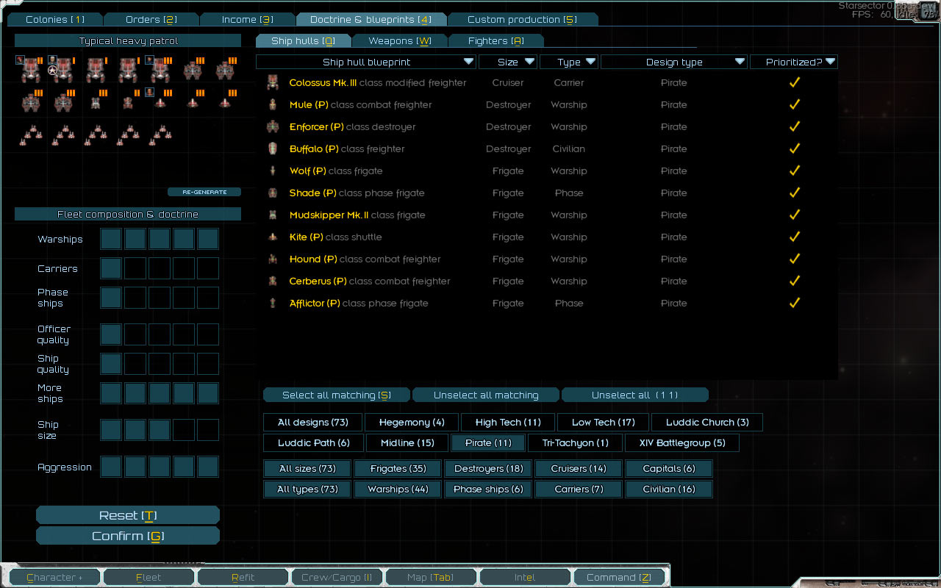](http://fractalsoftworks.com/wp-content/uploads/2018/02/composition.jpg)

The other goal is for everything to function smoothly if the player doesn’t even open this screen; both for the player that’s not particularly interested in this customization, and for the new player that doesn’t know about it. The flow should be “ah, I’d like the fleets my colonies launch to be different, how do I do that?”, not “everything is on fire, how do I fix it?”. That just involves having sensible defaults for everything, and having the always-available “base” set of blueprints goes a long way towards making sure things will work when left alone.

另一个设计目的是即使在玩家不使用这个界面的情况下，游戏仍然能正常进行。对于那些对魔改舰队不感兴趣的玩家和不知道怎么玩的新人，他们的反应应该是“啊，我想让从我的殖民地出发的舰队变得不同，应该如何去做？”，而不是“咋回事啊？啥玩意啊？咋整啊？”。这就解释了为什么要对所有的事情进行一个合理的默认设置，并设定一套“基本蓝图”以确保这个系统可以在无干预的情况下正常运行。

Faction Doctrine

势力设定

In addition to deciding what blueprints to use, the player can also specify some broad faction-wide settings for their fleets – a “doctrine”.

除了决定使用哪些蓝图之外，玩家也可以指定特定的派系“设定”

[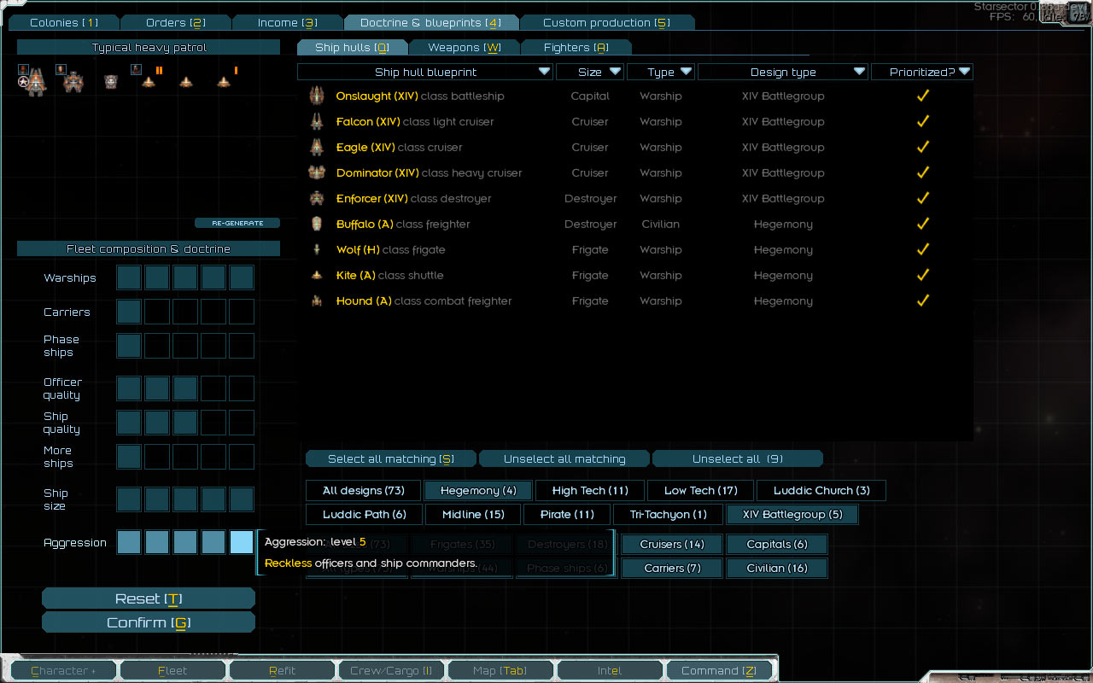](http://fractalsoftworks.com/wp-content/uploads/2018/02/doctrine.jpg)

The warships/carriers/phase ships set of selectors let the player set the overall ratio of those types of ships in their fleets, with 7 points to distribute among the three. They can also decide how much to favor officer quality, ship quality, and the number of ships, likewise with 7 points to distribute. (What’s “ship quality”? More on that in a bit!)

用于战舰、航母、相位船只比例的选择器可以让玩家设定舰队的整体组成，共有7个选择点数可以在这三项间分配。玩家也可以设定军官质量、舰船质量、舰船数量间的取舍，同样有7个选择点数可以分配。（稍后解释“舰船质量”）

Then there are two separate controls, one for ship size, and one for ship captain aggressiveness. There’s also a handy display showing a “typical” fleet using the current doctrine and blueprint configuration.

除此之外，还有一个用于设定舰船尺寸的选择器和一个设定舰船攻击性的选择器，以及一个人用于预览当前舰队配置下典型舰队的窗口。

Non-player factions are configured using the same set of doctrine controls (and, indeed, use the same concept of blueprint availability and prioritization).

非玩家势力也使用相同的原则控制系统，并且也存在相同的蓝图以及蓝图优先机制。

The aggressiveness control is particularly interesting because applies not just to officers, but to “default”, no-special-captain-assigned ship behavior. For example, pirates and pathers will have a high aggressiveness on all their ships. Alongside the other options, it’s a good one to have for differentiating the various factions a bit more.

“攻击性”是一个很有趣的选项，它不仅仅应用于拥有军官的舰船，也同样适用于没有分派军官的舰船。例如，海盗和守卫者舰队的所有舰船有较强的攻击性。攻击性是增大不同势力间区别的重要设定。

For example, pirates might have low ship quality, high numbers, and high aggressiveness. Tri-Tachyon (a technology-focused corporation) might have poor combat officers (more concerned with the business side of things), and low ship numbers, but high ship quality, along with low aggressiveness (all those repairs won’t pay for themselves!).

例如，海盗的舰队通常有较低的舰船质量，较高的舰船数目和较强的攻击性。速子（科技集团）通常有较低的军官质量（更倾向于商业），较低的舰船数量和较高的舰船质量。他们的攻击性较低（修船也是要花钱的！）。

Ship Production Quality

舰船生产质量

In the current release, certain factions use hulls with built-in d-mods (i.e., defective or damaged hulls, with subpar combat performance). Having a variable ship quality is a way to extend that concept to work on all sorts of ships, not just ones with hand-made (D) versions. Low production quality results in ships with more d-mods, and low quality ships are also less likely to be equipped with higher-tier weapons.

在当前版本中，部分势力使用内建有d船插的舰船（例如在战斗中表现欠佳的，有缺陷的或损坏的舰船）。不同于之前人工制造的d版本舰船，采取不同的舰船生产质量是将这一概念扩展到所有舰船上的一种方法。低质量的舰船通常带有更多的d船插，并且不太可能装配高端的武器。

In addition to the doctrine “ship quality” setting, ship quality can be increased by finding a “nanoforge” and installing it in a colony’s Heavy Industry. Various quality nanoforges can be found in the ruins on the fringes of the Sector. (Another instance of exploration contributing to colony development, if you’re keeping track!)

除了改变势力的“舰船质量”设置以外，也可以通过寻找“纳米锻造”并将其安装在殖民地的工厂中来提高所生产的舰船质量。在星区的边缘可以找到不同质量的“纳米锻造”。（另一个“探索支持殖民地发展”的例子）。

[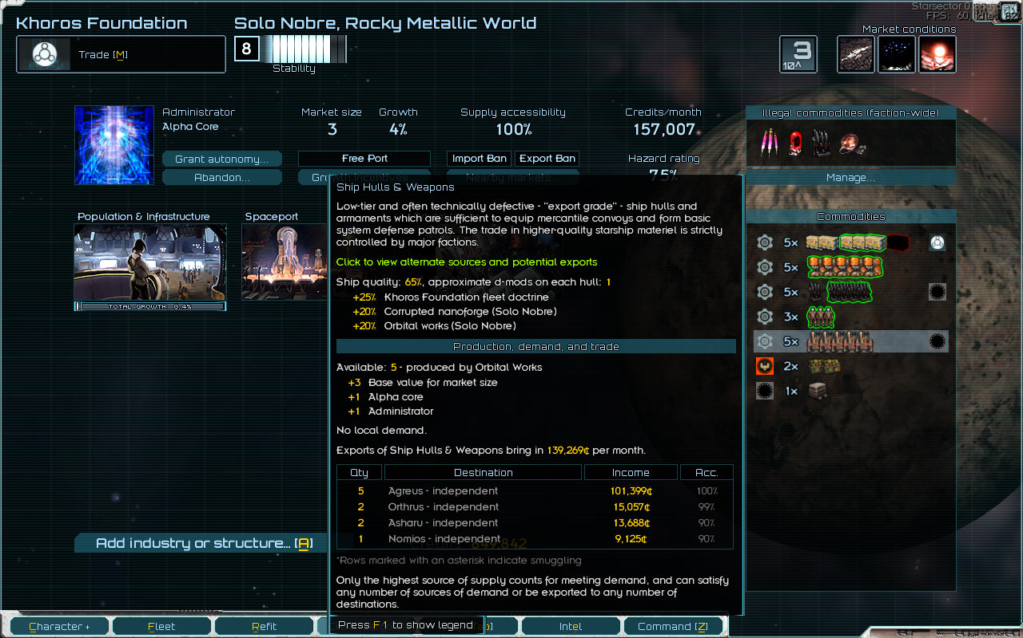](http://fractalsoftworks.com/wp-content/uploads/2018/02/ship_quality.jpg)

Not every colony is capable of ship production – in fact, most aren’t. Ship production is based off importing a “Ship Hulls & Weapons” commodity produced by Heavy Industry. When the supplier of ship hulls is in the same faction, all is well. When, on the other hand, ship supply is coming from another faction, it’s limited to clunkers – that is, there’s a significant quality penalty. The idea here is to encourage the player to develop their own heavy industry, but to also give them something to get off the ground with before that point.

并不是每一个殖民地都有能力制造舰船 – 实际上，大部分都没有。舰船的生产依赖于殖民地所进口的，由重工业基地所生产的船体与武器商品。当商品供应商与船只生产商在同一阵营时，一切都好说；但当供应来自于其他阵营时，仅仅能得到一些“旧货” – 明显的质量下降。这种设定旨在鼓励玩家建立自己的重工业体系，但同时也给予它们足够的支持以度过发展期。

Custom Production

自定义生产

We’ve covered fleet customization options, and a few things that grew out of that as far as general-purpose faction configuration. Now, the more basic feature – being able to build stuff from blueprints, for the player’s personal use.

我们已经介绍了舰队的自定义设置，以及由此产生的派系设定。现在，我们将介绍最为基础的部分 – 根据蓝图建造玩家个人所用的物品。

There’s a screen similar to the blueprint management one, but instead of prioritizing blueprints, it lets the player create a production order. The monthly production capacity depends on how much Heavy Industry the player’s colonies have. It’s expressed in credits, with ships, weapons, etc, costing about half of their normal purchase price to produce; the cost is added to the monthly income report. If an item costs more than the production capacity, it will take more than one month to finish.

用于供玩家制造舰船的界面与蓝图管理界面相似，但并非用于指定优先蓝图，而是用于给殖民地下达舰队制造订单。殖民地每月的生产容量，取决于殖民地所拥有的工业规模。生产容量以星币的方式计算，舰船、武器所对应的生产容量大约是其市价的一半。生产的消耗将会被计入月度收入报告中，并且如果生产的物品超过了殖民地的工业容量，物品则需要超过一个月才能制造完成。

The price point – roughly half of the purchase price – means that 1) it’s beneficial to custom-produce your own ships and weapons, but 2) it’s not profitable to do it just to sell them off.

物品所对应的生产容量大约相当于其市价的一半意味着：

1. 自己生产自己使用的舰船和武器是划算的。
2. 自己生产然后出售是不划算的。

The player can also choose a “gathering point” where the production order will be delivered, along with some fuel, supplies, and crew.

玩家亦可以选择生产订单所交付的“集结点”，携同一些燃料、补给以及船员。

[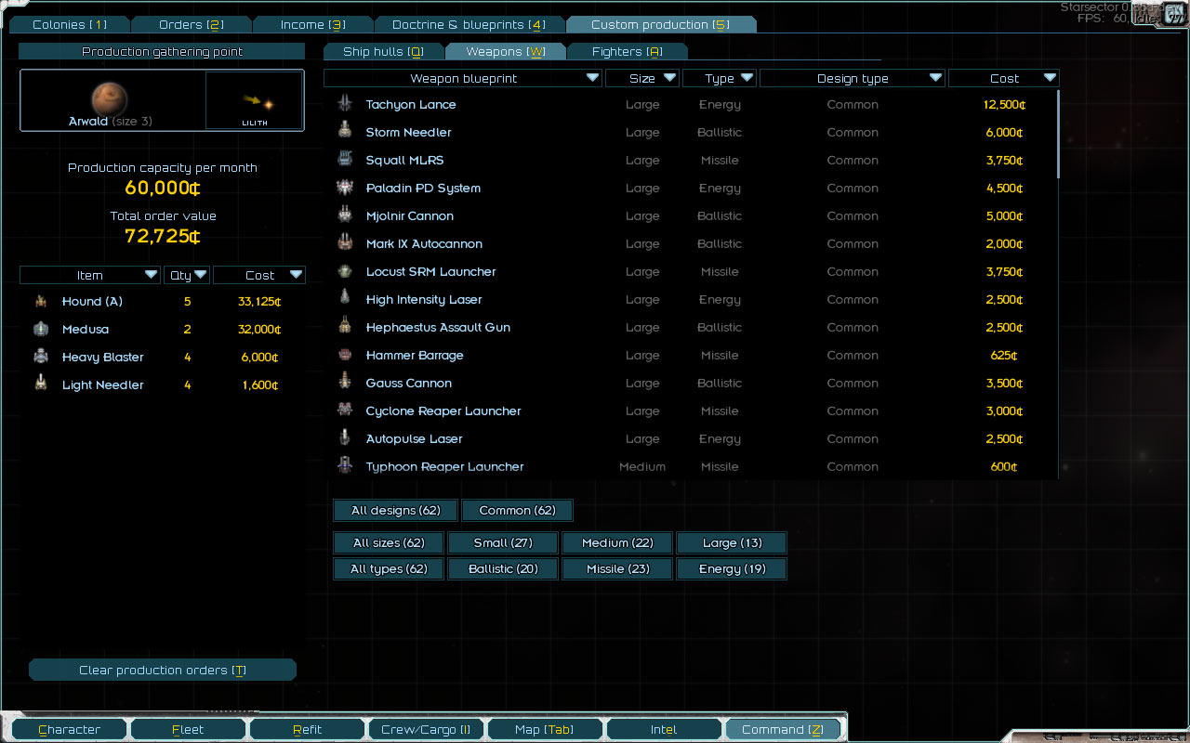](http://fractalsoftworks.com/wp-content/uploads/2018/02/production.jpg)

What’s interesting about this screen is that looking at it now, it’s very simple. You just click on things to produce them (or, er, control-click to produce more of them, but that’s a minor point), and there’s a cost limit. That’s it! But it started out a lot more complicated – the initial idea had the concept of how long something takes to build, a priority queue for the order in which things should be constructed, which colonies are working on which part of the order (and tracking the current progress), and so on.

现在看来，这个订单界面是十分简单的。你只需要在物品上单击即可生产它们（按住control点击来生产更多），并注意消耗上限，仅此而已。但之后，这个界面会逐渐变得更加复杂 – 一开始的想法还包括生产特定物品的时间，生产队列，不同殖民地的分工（并追踪当前进展），以及更多。

Now, I was never at a point where that mess was something I was happy with and wanted to actually build – it was a starting point to simplify from. It came to be from a “let’s think about how it would actually work” approach, or “realism” in some sense. And I did need a starting point, so it did the job of providing one.

目前，我正处于一种前所未有的，我所希望的，令人愉悦的的混乱局面中 – 这是一个简化的开端。我现在所做的，发源于我对于“这一切应当如何运作？”的思考，抑或是在某些情况下对于“现实主义”的追求。我的确需要一个开端，所以我创造了一个。

The key simplification was to take one step back in terms of abstraction and express production costs directly in credits. After all, at the level the player is operating on here, they really are just deciding how much money to throw at their problems – and this is consistent with other mechanics on the colony level, where credits are the primary resource. Once that became clear, everything else just fell into place, and the result is a screen which probably looks like it just came out fully-formed the way it did.

在这次的变化中，最为重要的一点，是使用星币直接来衡量生产所需的消耗，以减少游戏中的抽象性。总之，在玩家所操作的层面上，其作出的决定无非是“投入多少钱来解决问题”。这种决策机制与殖民地的其他一致，都将星币作为主要的资源。一旦确定了这一点，其他的问题都会落到实处，结果就是这个简单的界面，看起来完全符合其内在逻辑。

(There *is* one concession to realism here, however – most items have a hidden “how long would it take to build at a minimum” time. So regardless of the production capacity, if one queues up a battleship the day before the end of the month when custom production “ticks”, it’s not going to materialize out of thin air.)

（这里其实仍然有一些对于“现实主义”的让步：大部分的物品应当有其“最短建造时间”。所以，即使在工业容量足够的情况下，在月末生产容量重置的前一天订购一艘战舰，她并不应当在一天之内凭空出现。）

So, there you have it – blueprints, with a side order of faction customization!